SQL
Session-9
1.Create a SQL script to insert a new order into an Orders table, then use COMMIT to save the transaction and verify that the new order persists after reconnecting to the database
START TRANSACTION;

INSERT INTO Orders (order_id, user_id, order_total)
VALUES (1, 101, 1500.00);

COMMIT;
START TRANSACTION;

INSERT INTO Orders (order_id, user_id, order_total)
VALUES (1, 101, 1500.00);

COMMIT;
Output:
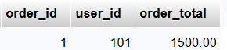

2.Simulate a Zomato-style food order process: insert two new items into an OrderItems table, then use ROLLBACK to undo the changes before committing. Check that no new items remain in the table after rollback.
CREATE TABLE OrderItems (
item_id INT PRIMARY KEY,
item_name VARCHAR(100),
price DECIMAL(10,2)
) ;
START TRANSACTION;

INSERT INTO OrderItems (item_id, item_name, price)
VALUES
(1, 'Pizza', 250.00),
(2, 'Burger', 150.00);

ROLLBACK;
Output:
SELECT * FROM OrderItems
WHERE item_id IN (1, 2);
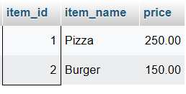

3.In a Flipkart-like shopping cart scenario, use SAVEPOINT to mark a point after adding a product to the Cart table, add another product, then use ROLLBACK TO SAVEPOINT to undo only the last addition. Show the final contents of the Cart table.
CREATE TABLE Cart (
cart_id INT PRIMARY KEY,
product_name VARCHAR(100),
price DECIMAL(10,2)
) ;
START TRANSACTION;

INSERT INTO Cart (cart_id, product_name, quantity)
VALUES (1, 'Laptop', 1);

SAVEPOINT product_added;

INSERT INTO Cart (cart_id, product_name, quantity)
VALUES (2, 'Mouse', 1);

ROLLBACK TO SAVEPOINT product_added;

SELECT * FROM Cart;

COMMIT;
Output:
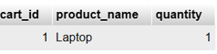
4.Write a trigger on a Wallet table that automatically deducts the purchase amount from the user's balance whenever a new transaction is inserted, similar to how Paytm updates wallet balance after a payment.
CREATE TABLE Wallet (
user_id INT PRIMARY KEY,
balance DECIMAL(10,2)
);
CREATE TABLE Transactions (
transaction_id INT PRIMARY KEY,
user_id INT,
amount DECIMAL(10,2)
);
INSERT INTO Wallet (user_id, balance)
VALUES
(1, 5000.00),
(2, 3000.00);

DELIMITER //

CREATE TRIGGER deduct_wallet_balance
AFTER INSERT ON Transactions
FOR EACH ROW
BEGIN
UPDATE Wallet
SET balance = balance - NEW.amount
WHERE user_id = NEW.user_id;
END //

DELIMITER ;
INSERT INTO Transactions (transaction_id, user_id, amount)
VALUES (101, 1, 1500.00);

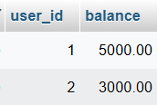

5.Use ChatGPT to generate a SQL test scenario where a trigger incorrectly updates a user's balance after an expense entry. Paste the scenario and your corrected trigger code, explaining how you fixed the error.<br><br><em><strong>Hint:</strong> Ask ChatGPT for a buggy trigger example and a test case that exposes the bug.</em>
CREATE TABLE Wallet (
user_id INT PRIMARY KEY,
balance DECIMAL(10,2)
);

CREATE TABLE Expenses (
expense_id INT PRIMARY KEY,
user_id INT,
amount DECIMAL(10,2)
);

INSERT INTO Wallet VALUES (3, 5000.00);
DELIMITER //

CREATE TRIGGER buggy_expense_trigger
AFTER INSERT ON Expenses
FOR EACH ROW
BEGIN
UPDATE Wallet
SET balance = balance + NEW.amount
WHERE user_id = NEW.user_id;
END //

DELIMITER ;

INSERT INTO Expenses
VALUES (102, 2, 1000.00);

SELECT * FROM Wallet;
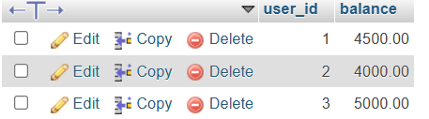
DROP TRIGGER buggy_expense_trigger;

DELIMITER //

CREATE TRIGGER correct_expense_trigger
AFTER INSERT ON Expenses
FOR EACH ROW
BEGIN
UPDATE Wallet
SET balance = balance - NEW.amount
WHERE user_id = NEW.user_id;
END //

DELIMITER ;
INSERT INTO Expenses
VALUES (103, 1, 1000.00);
SELECT * FROM Wallet;
